LAB TASK 2.1
Write an Assembly program that:
- Moves the value 15h into register AL and the value 25h into register BL using the MOV
- instruction.
- Copies the contents of AL into CL using the MOV instruction.
- Exchanges the contents of AL and BL using the XCHG instruction
RESULTS:
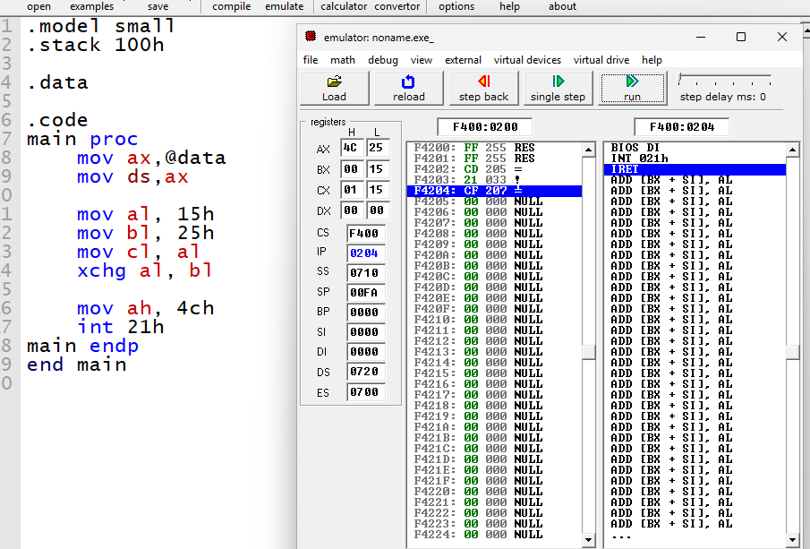
DESCRIPTION:
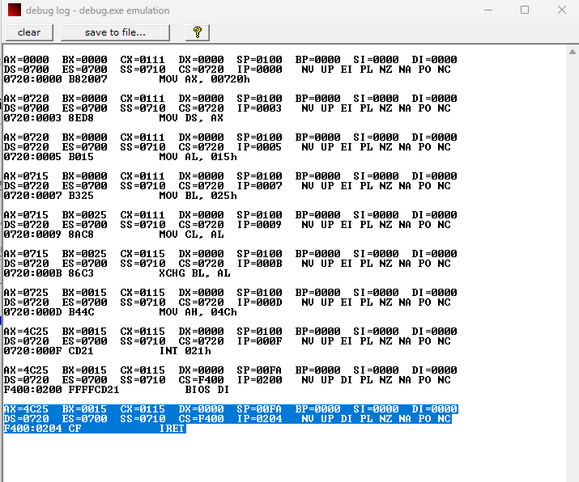
LAB TASK 2.2
8-bit Registers with MOV and XCHG
- Initialize AL, BL, CL, and DL with different values.
- Use MOV to copy BL into AL and DL into CL.
- Use XCHG to swap AL and DL.
- Observe changes in the register window after execution.
ANSWER:
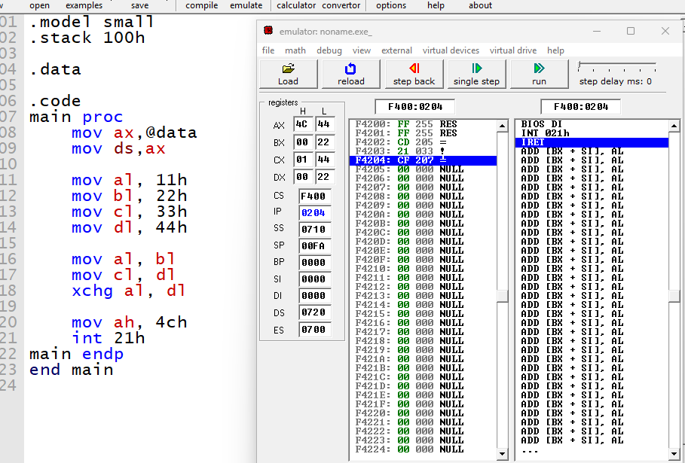
DESCRIPTION:
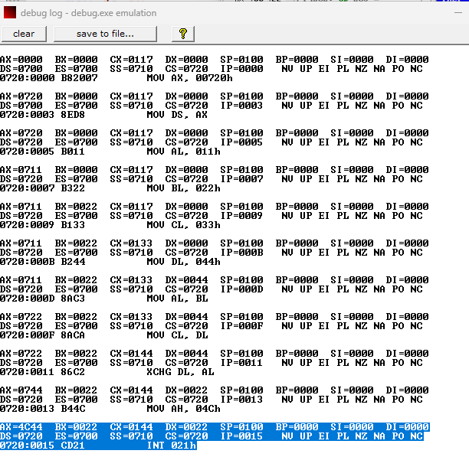
LAB TASK 2.3
16-bit Registers with MOV and XCHG
- Initialize AX, BX, CX, and DX with different values.
- Use MOV to copy BX into AX and DX into CX.
- Use XCHG to swap AX and DX.
- Observe changes in the register window after execution.
ANSWER:
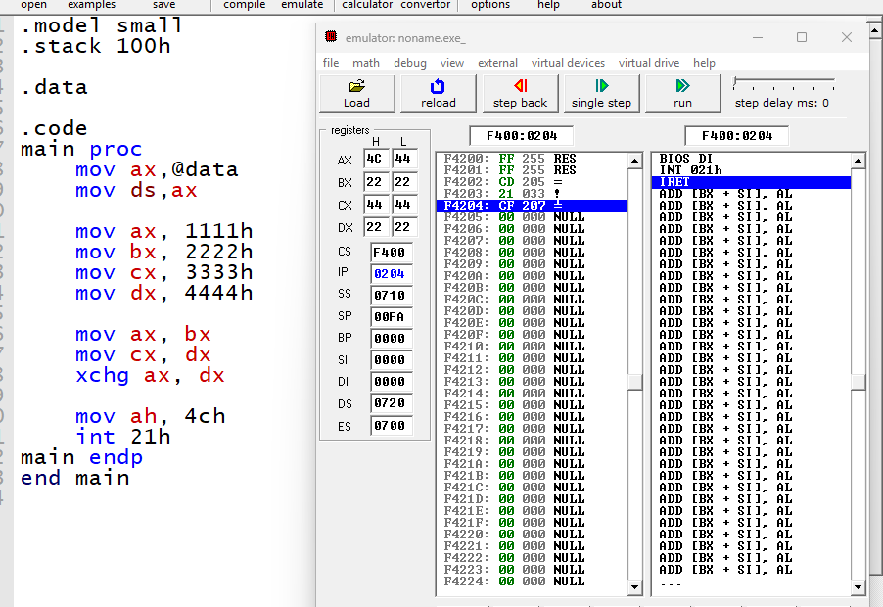DESCRIPTION
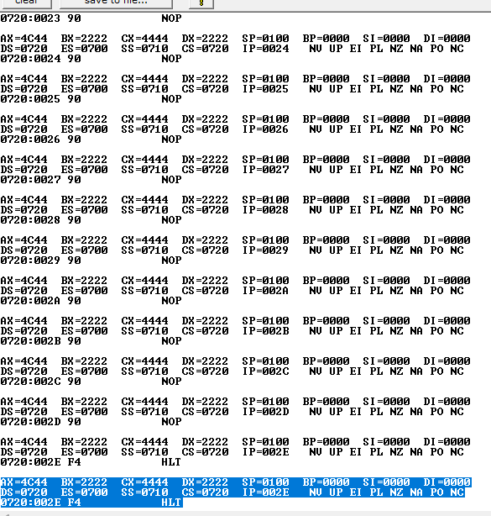
LAB TASK 2.4
Write a set of instructions in x86-64 assembly language that swaps the contents of upper
and lower bytes in BX register.
ANSWER:

